 | YEAR 12 MATHEMATICS SPECIALIST  SEMESTER TWO 2017  QUESTIONS OF REVIEW 5: Differentiation  with Applications

Name: _______________________

Thursday 29th June Time: 35 minutes Mark /30
CAS free, scientific calculator allowed.

[7 marks – 1, 3 and 3]
A curve is defined by the equation

Verify that lies on the curve

Develop an expression for the gradient function

Determine an equation for the normal to the curve at .

[4 marks]
A particle with displacement has velocity .
Show that the acceleration is constant and evaluate this constant.

[6 marks – 3, 2 and 1]
A second charged particle in a magnetic field has velocity cm/sec when it has travelled x cm from rest.

Show that, if and represent small changes in x and v respectively,

Estimate the percentage change in x needed to reduce v by 4%.

Explain whether this is a valid method to estimate the effect of a 50% change in x.

[8 marks – 4, 1, 1 and 2]
A damaged oil tanker is leaking oil into the sea. A current pushes the spreading oil into the shape of a sector of a circle, with radius and sector angle . Both and change with time.
The area of a sector is given by .

Show that

The radius of the oil spill is increasing at 2 m per minute and the area at 2π m² per minute.

When the oil spill has a radius of 6 m:

determine the area at this instant

find the exact value of at this instant

calculate the rate of change of at this instant.

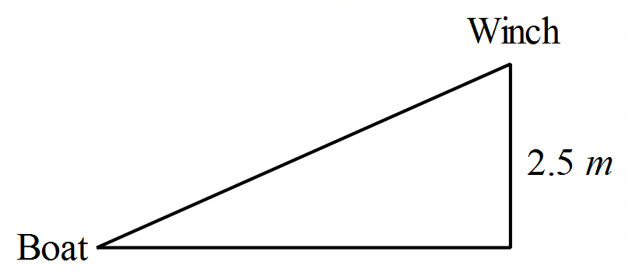[5 marks]
A small boat is being hauled towards a wharf by a winch mounted 2.5 m above water level. The winch is pulling the connecting rope at a rate of 0.06 m per second.

How fast is the boat moving horizontally when there is 6.5 of rope between the boat and the winch?

